Experiment 5

Student Name: Lakshay Aggarwal UID: 25MCI10047
Branch: MCA (AI/ML) Section/Group: 25MAM-1(A)
Semester: 2-SEM Date of Performance: 03/03/2026
Subject Name: Technical Training - 1 Subject Code: 25CAP-652

- Aim of the Session:

To gain hands-on experience in creating and using cursors for row-by-row processing in a database, enabling sequential access and manipulation of query results for complex business logic.

- Software Requirements:
- PostgreSQL
- pgAdmin
- Windows Operating System

- Objectives of the Session:
- Sequential Data Access: To understand how to fetch rows one by one from a result set using cursor mechanisms.
- Row-Level Manipulation: To perform specific operations or calculations on individual records that require conditional procedural logic.
- Resource Management: To learn the lifecycle of a cursor: Declaring, Opening, Fetching, and importantly, Closing and Deallocating to manage system memory.
- Exception Handling: To handle cursor-related errors and performance considerations during large-scale data iteration.

- Theory:

While SQL is generally set-oriented, certain tasks require a procedural approach where we process one row at a time. This is where Cursors are used:
- Cursor Types: Cursors can be Implicit (managed by the system) or Explicit (defined by the developer). They can also be Forward-Only (moving only toward the end) or Scrollable (moving back and forth).
- The Lifecycle: * DECLARE: Defines the SQL query for the cursor.
  - OPEN: Executes the query and establishes the result set.
  - FETCH: Retrieves a specific row into variables for processing.
  - CLOSE: Releases the current result set.
  - DEALLOCATE: Removes the cursor definition from memory.
- Use Case: Cursors are ideal for generating row-specific reports, updating balances based on complex historical data, or migrating data where each record needs individual validation.

- Practical / Experiment Steps:

Step 0: Creating a sample table and inserting records

Code:

CREATE TABLE employee(

emp_id serial primary key,

emp_name varchar(50),

experience int,

performance_score int,

salary int

);

insert into employee (emp_name, experience, performance_score, salary) values

('tushar', 2, 6, 30000),

('priya', 5, 8, 50000),

('neha', 1, 5, 25000),

('lakshay', 7, 9, 70000),

('sam', 3, 6, 35000);

SELECT * FROM employee;

Output:

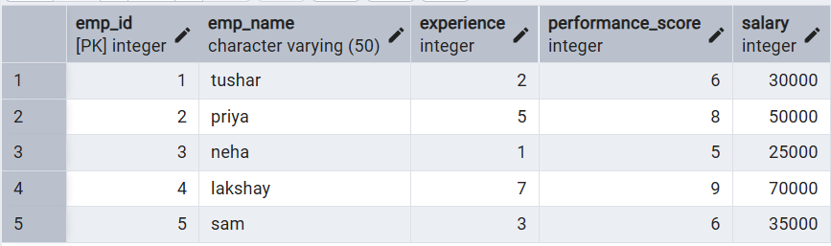

Step 1: Implementing a single Forward-only cursor

Creating a cursor to loop through an Employee table and print individual records.

Code:

DO $$

DECLARE

emp_rec RECORD;

emp_cursor CURSOR FOR

SELECT emp_id, emp_name, salary FROM employee;

BEGIN

OPEN emp_cursor;

LOOP

FETCH emp_cursor INTO emp_rec;

EXIT WHEN NOT FOUND;

RAISE NOTICE 'ID: %, Name: %, Salary: %',

emp_rec.emp_id,

emp_rec.emp_name,

emp_rec.salary;

END LOOP;

CLOSE emp_cursor;

END $$;

Output:

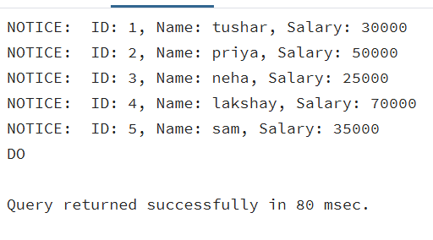

Step 2: Complex Row-by-Row Manipulation

Using a cursor to update salaries based on a dynamic "Experience-to-Performance" ratio logic.

Code:

DO $$

DECLARE

emp_rec RECORD;

increment_amount INT;

emp_cursor CURSOR FOR

SELECT emp_id, experience, performance_score, salary

FROM employee;

BEGIN

OPEN emp_cursor;

LOOP

FETCH emp_cursor INTO emp_rec;

EXIT WHEN NOT FOUND;

increment_amount :=

emp_rec.experience * emp_rec.performance_score * 500;

UPDATE employee

SET salary = salary + increment_amount

WHERE emp_id = emp_rec.emp_id;

RAISE NOTICE 'Emp ID % salary increased by %',

emp_rec.emp_id,

increment_amount;

END LOOP;

CLOSE emp_cursor;

END $$;

Output:

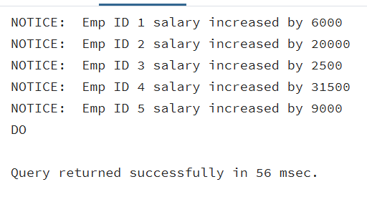

Step 3: Exception and Status Handling

Ensuring the cursor handles empty result sets or termination signals gracefully.

Code:

DO $$

DECLARE

emp_rec RECORD;

emp_found BOOLEAN := FALSE;

emp_cursor CURSOR FOR

SELECT * FROM employee WHERE experience > 20;

BEGIN

OPEN emp_cursor;

LOOP

FETCH emp_cursor INTO emp_rec;

EXIT WHEN NOT FOUND;

emp_found := TRUE;

RAISE NOTICE 'Employee: %, Experience: %',

emp_rec.emp_name,

emp_rec.experience;

END LOOP;

CLOSE emp_cursor;

IF emp_found = FALSE THEN

RAISE NOTICE 'No employees found for given criteria.';

END IF;

EXCEPTION

WHEN OTHERS THEN

RAISE NOTICE 'Error occurred: %', SQLERRM;

END $$;

Output:

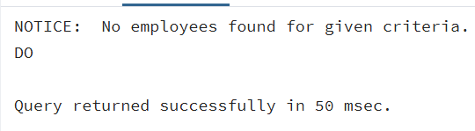
- Learning Outcomes (What I have learned):
- Cursor Implementation: Students will be able to design, implement, and manage cursors to solve row-wise processing problems.
- Lifecycle Mastery: Students will demonstrate the correct syntax for declaring, opening, fetching, and closing cursors.
- Error Prevention: Students will understand how to properly handle row-by-row processing exceptions and prevent memory leaks via deallocation.
- Analytical Thinking: Students will be able to apply cursor-based logic to solve real-world scenarios like multi-level payroll adjustments or data migrations.

